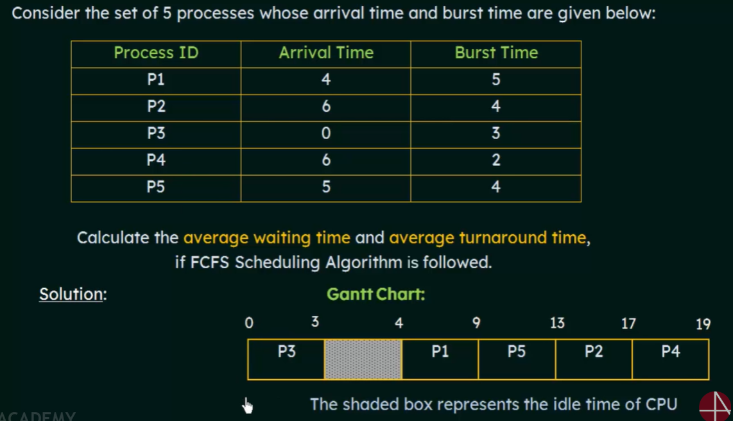

* **Throughput:** 5 processes / 19 time units ≈ 0.26 processes per time unit.
* **Completion Time (CT):** 
  + P1: 9
  + P2: 17
  + P3: 3
  + P4: 19
  + P5: 13
* **Waiting Time (WT):** Start Time – Arrival Time
  + P3: 0
  + P1: 0
  + P5: 4
  + P2: 7
  + P4: 11
* **Response Time:** Start Time – Arrival Time
  + P3: 0
  + P1: 0
  + P5: 4
  + P2: 7
  + P4: 11
* **Turnaround Time (TAT):** Completion Time – Arrival Time
  + P3: 3 - 0 = 3
  + P1: 9 - 4 = 5
  + P5: 13 - 5 = 8
  + P2: 17 - 6 = 11
  + P4: 19 - 6 = 13
* **Average Turnaround Time:** (3 + 5 + 8 + 11 + 13) / 5 = 40 / 5 = 8
* **Average Waiting Time:** (0 + 0 + 4 + 7 + 11) / 5 = 22 / 5 = 4.4
* **Average Response Time:** (0 + 0 + 4 + 7 + 11) / 5 = 22 / 5 = 4.4

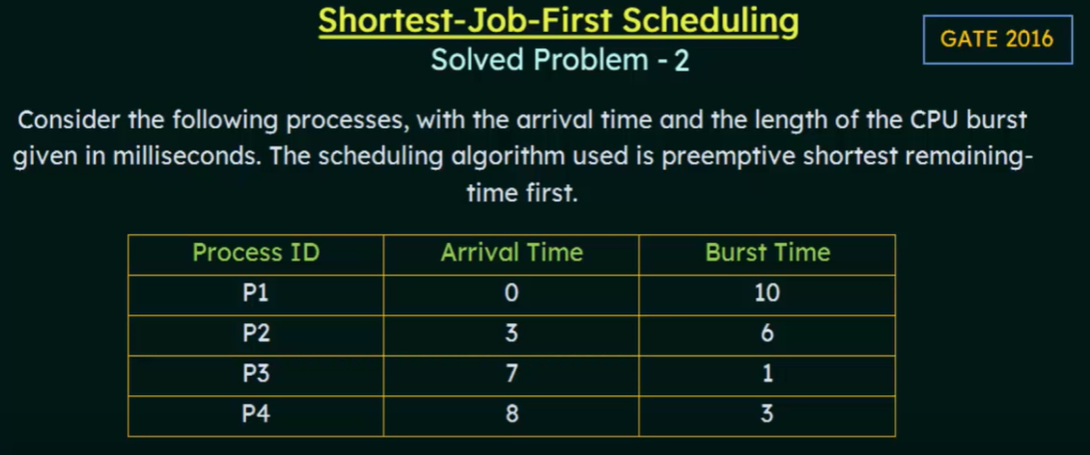

* **Shortest-Job-First (SJF) (Pre-emptive) = Shortest-Remaining-Time-First (SRTF).**
* **Shortest Job Next (SJN), also known as Shortest Job First (SJF).**
* **If two process have the same next CPU burst length, then FCFS breaks the tie.**
* **SJF is also known as Shortest-Next-CPU-Burst-Scheduling (SNCB) algorithm.**
* **SJF is optimal – gives minimum average waiting time for a given set of processes.**
* **The difficulty is knowing the length of the next CPU request.**

**Completion Time (CT):**

* P1: 20
* P2: 10
* P3: 8
* P4: 13

**Turnaround Time (TAT):** Completion Time - Arrival Time

* P1: 20 - 0 = 20
* P2: 10 - 3 = 7
* P3: 8 - 7 = 1
* P4: 13 - 8 = 5

**Waiting Time (WT):** Turnaround Time - Burst Time

* P1: 20 - 10 = 10
* P2: 7 - 6 = 1
* P3: 1 - 1 = 0
* P4: 5 - 3 = 2

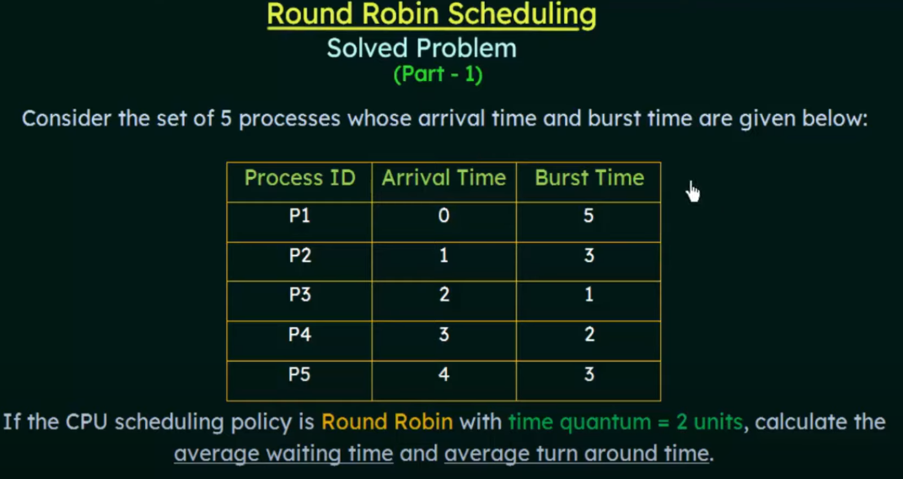

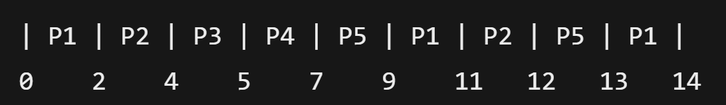

* **Processes with the same priority run round-robin.**

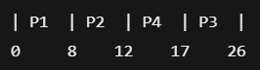

**Completion Time (CT):**

* P1: 8
* P2: 12
* P3: 26
* P4: 17

**Turnaround Time (TAT):** Completion Time - Arrival Time

* P1: 8 - 0 = 8
* P2: 12 - 1 = 11
* P3: 26 - 2 = 24
* P4: 17 - 3 = 14

**Waiting Time (WT):** Turnaround Time - Burst Time

* P1: 8 - 8 = 0
* P2: 11 - 4 = 7
* P3: 24 - 9 = 15
* P4: 14 - 5 = 9

**Average Turnaround Time (Avg. TAT):** (8 + 11 + 24 + 14) / 4 = 57 / 4 = 14.25

**Average Waiting Time (Avg. WT):** (0 + 7 + 15 + 9) / 4 = 31 / 4 = 7.75

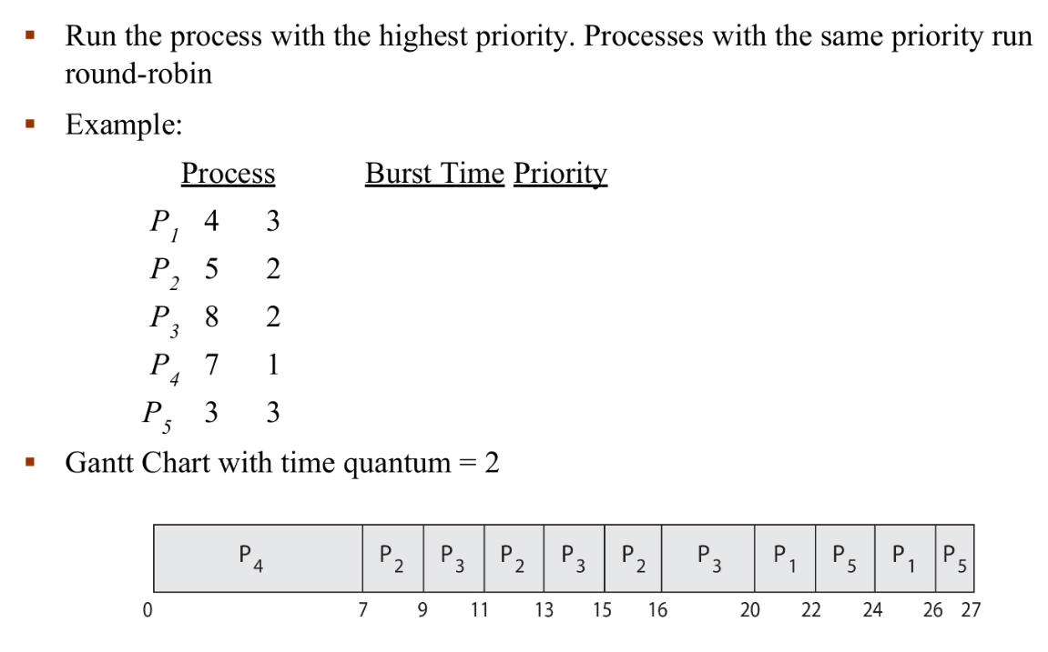

**Problem ≡** Starvation – low priority processes may never execute

**Solution ≡** Aging – as time progresses increase the priority of the process